Bundler (Ruby)
# Source: AI Source: Provided by: [Data Path: Persons Table -> ID Column: 1, Name_En Column: Motasem Essam] -> From: [ChatGPT] on [1/26/2026]
Bundler is a dependency manager for Ruby that ensures your application uses the correct versions of libraries (gems) it needs.
👉 Think of it like a package organizer: it installs and locks the exact versions of libraries so your app works consistently everywhere.

⚙️ What Bundler Does:
# Source: AI Source: Provided by: [Data Path: Persons Table -> ID Column: 1, Name_En Column: Motasem Essam] -> From: [ChatGPT] on [1/26/2026]
● Installs required Ruby libraries (gems)
● Manages project dependencies
● Locks exact versions using Gemfile.lock
● Ensures consistent environments across machines
● Works with RubyGems ecosystem

✅ Why Use Bundler?
# Source: AI Source: Provided by: [Data Path: Persons Table -> ID Column: 1, Name_En Column: Motasem Essam] -> From: [ChatGPT] on [1/26/2026]
Feature Description
📦 Dependency Management Installs and manages required gems
🔒 Version Locking Ensures same versions via Gemfile.lock
🔁 Reproducibility Same setup across all environments
🧠 Simplicity Easy commands and configuration
🤝 Collaboration Prevents “it works on my machine” issues

📄 Gemfile
# Source: AI Source: Provided by: [Data Path: Persons Table -> ID Column: 1, Name_En Column: Motasem Essam] -> From: [ChatGPT] on [1/26/2026]
A Gemfile is a configuration file for Ruby projects that lists all the gems (libraries) your application needs.
👉 Think of it like a shopping list: it tells Bundler what to install for your project.

⚙️ What a Gemfile Contains:
# Source: AI Source: Provided by: [Data Path: Persons Table -> ID Column: 1, Name_En Column: Motasem Essam] -> From: [ChatGPT] on [1/26/2026]
● Source → where gems are downloaded from (usually https://rubygems.org)
● Gems → names and optional versions of libraries your project requires
● Groups → optional categories (e.g., :development, :test)

✅ Example Gemfile
# Source: AI Source: Provided by: [Data Path: Persons Table -> ID Column: 1, Name_En Column: Motasem Essam] -> From: [ChatGPT] on [1/26/2026]
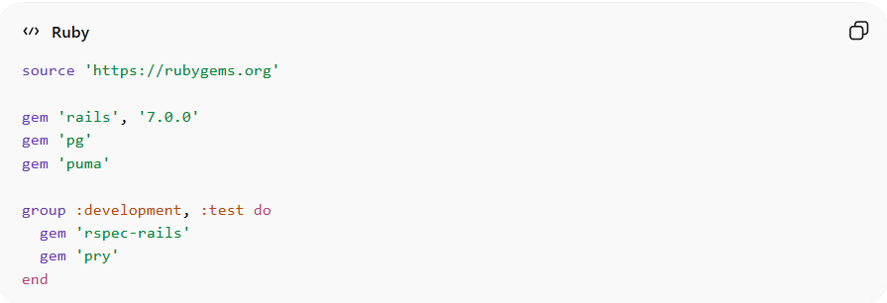
source 'https://rubygems.org'

gem 'rails', '7.0.0'
gem 'pg'
gem 'puma'

group :development, :test do
gem 'rspec-rails'
gem 'pry'
end

🧠 How Bundler Uses Gemfile
# Source: AI Source: Provided by: [Data Path: Persons Table -> ID Column: 1, Name_En Column: Motasem Essam] -> From: [ChatGPT] on [1/26/2026]
- Reads the Gemfile
- Downloads all listed gems
- Generates Gemfile.lock to lock exact versions
- Ensures consistent environment across all machines

⚡ Why Gemfile is Important
# Source: AI Source: Provided by: [Data Path: Persons Table -> ID Column: 1, Name_En Column: Motasem Essam] -> From: [ChatGPT] on [1/26/2026]
• Centralizes project dependencies
• Prevents version conflicts
• Works with Bundler to reproduce the environment anywhere
• Supports grouping by environment (:test, :development)

⚠️ Important Notes
# Source: AI Source: Provided by: [Data Path: Persons Table -> ID Column: 1, Name_En Column: Motasem Essam] -> From: [ChatGPT] on [1/26/2026]
• Must be named Gemfile (capital G, no extension)
• Run bundle install after editing to update gems
• Always commit Gemfile.lock to version control

🧠 Quick Summary
# Source: AI Source: Provided by: [Data Path: Persons Table -> ID Column: 1, Name_En Column: Motasem Essam] -> From: [ChatGPT] on [1/26/2026]
Gemfile = Shopping list of gems for Ruby projects
✔ Lists required gems
✔ Supports versioning
✔ Works with Bundler for reproducible setups

▶️ Common Bundler Commands
# Source: AI Source: Provided by: [Data Path: Persons Table -> ID Column: 1, Name_En Column: Motasem Essam] -> From: [ChatGPT] on [1/26/2026]
📥 Install dependencies:
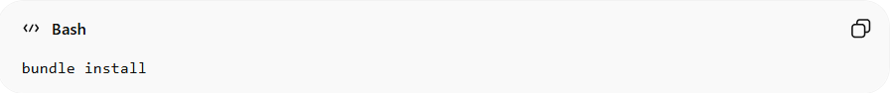
bundle install
🔄 Update gems:
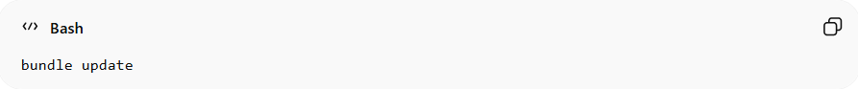
bundle update
▶️ Run app with dependencies:
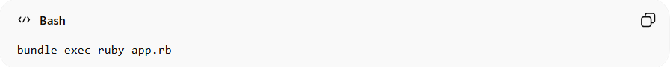
bundle exec ruby app.rb
📦 Add a gem:
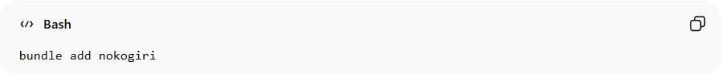
bundle add nokogiri

📁 Important Files
# Source: AI Source: Provided by: [Data Path: Persons Table -> ID Column: 1, Name_En Column: Motasem Essam] -> From: [ChatGPT] on [1/26/2026]
File Description
Gemfile List of required gems
Gemfile.lock Locked versions of all dependencies

⚠️ Limitations of Bundler
# Source: AI Source: Provided by: [Data Path: Persons Table -> ID Column: 1, Name_En Column: Motasem Essam] -> From: [ChatGPT] on [1/26/2026]
• Works only with Ruby ecosystem
• Can be slow with large dependency trees
• Requires understanding of Gemfile syntax

🧠 Bundler vs npm (Example)
# Source: AI Source: Provided by: [Data Path: Persons Table -> ID Column: 1, Name_En Column: Motasem Essam] -> From: [ChatGPT] on [1/26/2026]
Feature Bundler (Ruby) npm (JavaScript)
File Gemfile package.json
Lock File Gemfile.lock package-lock.json
Packages Gems Packages
Language Ruby JavaScript

🧠 Quick Summary
# Source: AI Source: Provided by: [Data Path: Persons Table -> ID Column: 1, Name_En Column: Motasem Essam] -> From: [ChatGPT] on [1/26/2026]
Bundler = Dependency manager for Ruby
✔ Uses Gemfile
✔ Locks versions with Gemfile.lock
✔ Ensures consistent environments

